ON CALCULATION OF INTEGRAL PARTS OF MOTION
IN THE THREE-DIMENSIONAL WIND FLOWS MODEL

Iliar Turdushev¹, Sergey Skliar^{1,2}
¹KRSU, Kyrgyzstan, Bishkek; ²AUCA, Kyrgyzstan, Bishkek
iliar.turdushev@gmail.com, sklyar51@gmail.com
Introduction
In general, formulation the mathematical model of wind flows of liquid in reservoir is described by the non-stationary initial-boundary value problem for the system of nonlinear equations, which can be solved only using numerical methods [1]. Taking into account the specific of Issyk-Kul Lake the general model was simplified and some classes of its analytical solutions in the areas of special form were found in [2]. The algorithms of the model suppose calculation of the integral parts U and V of the horizontal components of the velocity vector. In this paper new projective difference schemes for the integral parts U and V are developed by method described in [3, 4].
1. Statement of problem
Consider the following system of equations for the integral parts U and V of the horizontal components of the velocity [2]:

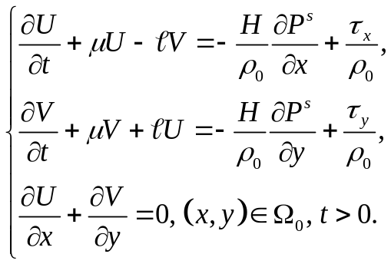
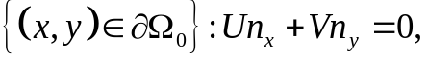
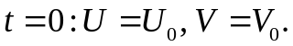

Where 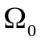 is two-dimensional area with boundary 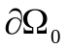 that describes the surface of reservoir. In (1)-(3) the following notations are used: U = U(t, x, y) and V =V (t, x, y) are integral parts of the horizontal components of velocity vector; 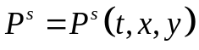 is a pressure on the undisturbed surface ; 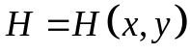 describes the bottom contour of reservoir; 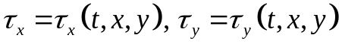 are the components of the tangential stress of wind friction; 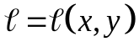 is a Coriolis force; 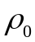 is the mean value of density; 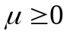 is a parameter that defines a bottom friction; 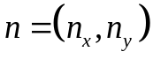 is a vector of an outer normal of the boundary of the area .

2. Main result
Differential scheme to solve the system (1)-(3) is constructed in two stages. On the first stage we approximate the system by the time variable and on the second stage – by the space variable.
Let’s describe an approximation by the time variable. To make this we introduce a complex velocity 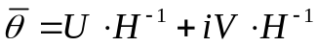 and rewrite the first two equations of in the following form:
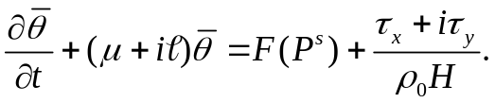
We build the approximation of using the method described in [3, 4]. For this purpose we multiply by the arbitrary test function 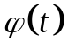 and integrate it along the cell 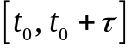. We obtain the next integral identity:
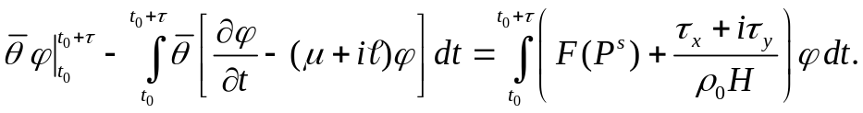
Then choose the test function that satisfies the following conditions:
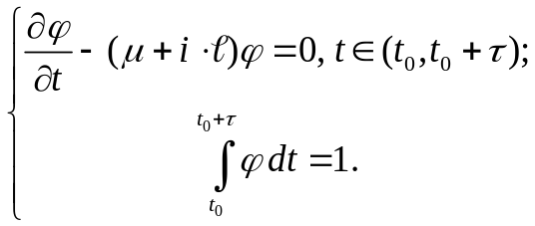
Such choice of allows us to get rid of main integral in the left part of . Then approximating the rest integrals using quadrature formulas and returning to the integral velocities U and V we obtain the next system of equations:
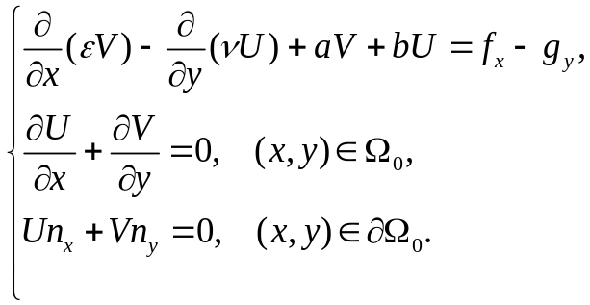
where 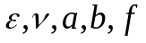 and 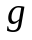 are known functions.
Here we begin the second stage of the constructing of the differential scheme – approximating by the space variables. Let’s consider arbitrary rectangular grid in the domain . Let 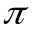 be its arbitrary cell. Let’s multiply the first equation of by the test function 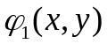 and the second equation by the test function 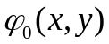, then sum up the results and integrate in the cell . As a result, we obtain the next integral identity:
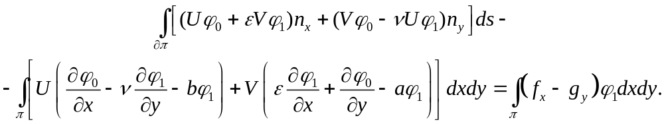
We choose test functions and as the solutions of the system of equations
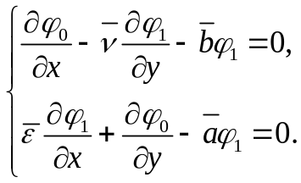
Such choice of the test functions allows us to get rid of the second integral in the left part of . Then approximating the rest integrals in using quadrature formulas we obtain a differential scheme for calculating U and V. When integrating in the right part of we use the formulas of integration by parts to move derivatives from functions f and g to the function .
This result was briefly described in [5].
3. Numerical experiment
To test the efficiency of the constructed differential scheme a computer program was developed. It computed an approximate solution for the test problem - under special conditions [2]:
- a reservoir of rectangular form with the constant depth was considered;
- the components of the tangential stress of wind friction were given in special analytical form;
- the Coriolis force was given as a liner function of argument y.

The results of experiments showed that developed differential scheme were efficient to solve the problem -. The relative error of approximate solution was less than 10%. We compared our scheme with another one developed in [6]. According to the results of the numerical experiments, our scheme was more accurate than the scheme from [6].
We also calculated integral parts U and V of velocity vector for the case of Issyk-Kul Lake relief.
Conclusion
The results of numerical experiments showed that our scheme is efficient and therefore it is possible to use the new method for the computing of integral parts of velocity in general three-dimensional wind flows model.

REFERENCES
1. Marchuk G.I., Sarkisyan A.S. (1988) Mathematical modeling of circulation of ocean (in Russian). Science, Moscow, 302 p.
2. Turdushev I.A., Skliar S.N. (2013) Analytical solutions for the three-dimensional model of wind flows in reservoir (in Russian). / Actual problems of control theory, topology and operator equations: Materials of the second international conference devoted to the twentieth anniversary of the foundation of Kyrgyz-Russian Slavic University and centenary of the professor Y.V. Bykov (Kyrgyzstan, Bulan-Sogottu, 5-7 September, 2013) / Ed. Kerimbekov. A.K. Bishkek: Publishing house Maxprint. Vol. 2, pp. 214-218.
3. Eremeev V.N., Kochergin V.P., Kochergin C.V., Skliar S.N. (2002) Mathematical modeling of hydrodynamics in deep-water reservoirs (in Russian). “EKOSI-Hydro physics”, Sevastopol, 238 p.
4. Skliar S.N. (1988-1989) On discretization of problems with boundary layer using the projective method of integral identities (in Russian). I. Nonself-adjoint equation, first boundary problem // Proceedings of Academy of Sciences of Kyrgyz SSR. Physical-technical and mathematical sciences. – 1988. – #4. – PP. 10-23. II. Nonself-adjoint equation, third boundary problem // Ibid. - 1989. - #1. – PP. 3-10. III. Sefl-adjoint equation // Ibid. - 1989. - #4. – PP. 3-11.
5. Turdushev I., Skliar S. (2014) On calculation of integral parts of motion in the three-dimensional wind flows model. Abstracts of V Congress of the Turkic World Mathematicians (Kyrgyzstan, Bulan-Sogottu, 5-7 June, 2014) / Ed. A.Borubaev. Bishkek: Kyrgyz Mathematical Society. – P. 257.
6. Skliar S.N., Rylov M.A. Computing of barotropic components of motion in problems of water circulation in reservoir (in Russian). Study of the Issyk-Kul lake hydrodynamics with the use of isotopic methods, ISTC, Bishkek, Ilim, 2006, Part-II, P. 21-30.

